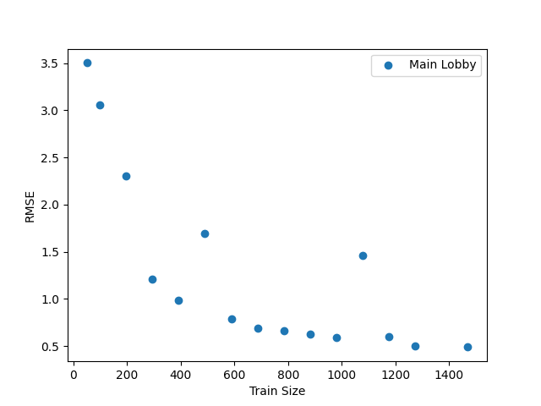

Constant:

* Model
* Training Data

Testing:

* Different training size and the RMSE result.

Result:

* The graph shows a negative association in which the RMSE decreases as the train size gets bigger. We can see that there is an outlier at 1078 train size. However, throughout the model, the trend continues. It also showed a consistent pattern and without that big outlier at 1078 when 4 trials have taken place and then averaged.

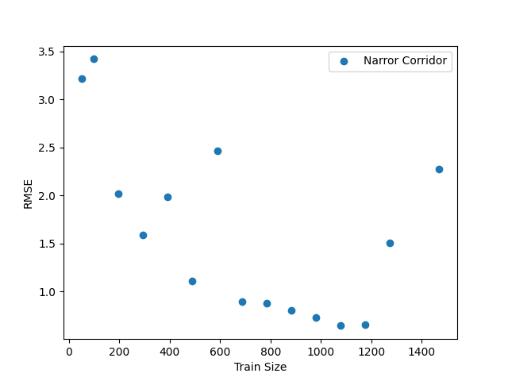

Constant:

* Model
* Training Data

Testing:

* Different training size and the RMSE result.

Result:

* The graph shows a negative association in which the RMSE decreases as the train size gets bigger. However, after 1200, there is a big increase in the RMSE. Furthermore, when the 4 runs took place, the smallest result was also 1176.

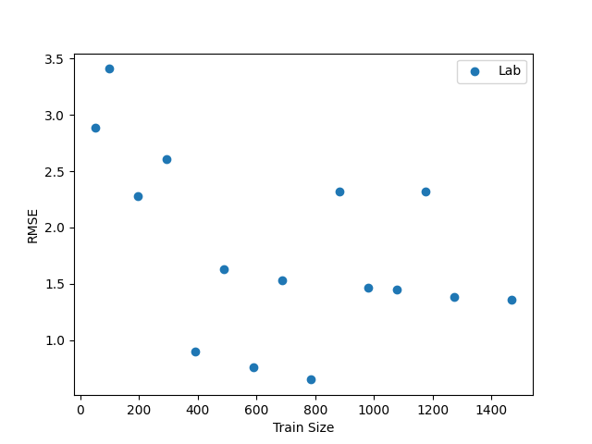

Constant:

* Model
* Training Data

Testing:

* Different training size and the RMSE result.

Result:

The graph does not show any trend and it fluctuates throughout the graph. The best point was at 784 train size. The mean result also showed no trend, and the lowest point was at 784.

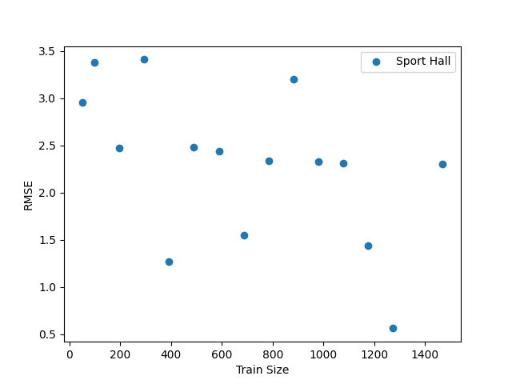

Constant:

* Model
* Training Data

Testing:

* Different training size and the RMSE result.

Result:

The graph shows a somewhat weak association. The graph also fluctuates. Moreover, the lowest point was at 1274 train size, and the 1470 train size had a bigger RMSE. The mean showed a stronger trend and the lowest point, however, was at 1176 with around 1.22 RMSE.